Requirements Engineering Document

Group 11

Alexander Wojtowicz-Forte – 500658355

Christopher Papanagiotou – 500613906

Edgar Safaryan – 500579814

Jermaine Ganado – 500624506

Joseph Chan – 500583984

Maaz Jawed – 500591818

March 12, 2016

**Architecture Style**

Our architectural style is combination of the 3 tier layered architecture and an object oriented architecture. We have a presentation tier, which is the UI component. We have a logic tier, which is all the logical decisions and processes commands such as getCardNumber(), getPin(), withdraw(), and etc. We also have a data tier, which is the account numbers and card information which held in a database which is also passed down to the logic tier such as getCardNumber() retrieves the stored card number from the database.

Presentation Tier

Logic Tier

Data Tier

**Package Diagram**

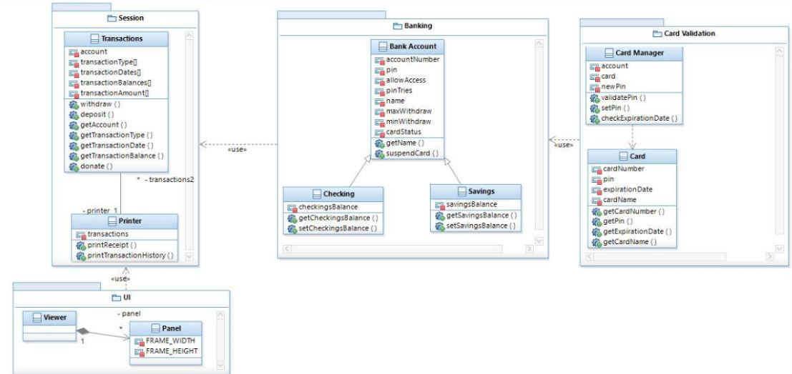

The UI package displays the login panel at first. After a successful login, withdraw, deposit, view account info, and exit are displayed as options to choose from. Each option has their own panel to display.

The Session package is made for each time a person logs in. It tracks the transactions and can print out the history of these transactions.

The Banking package represents a banking account that tracks a balance to a unique person. It can be implemented as a chequing or savings account.

The Card Validation package check if the pin and card number match a possible banking account.

**Class Diagram**

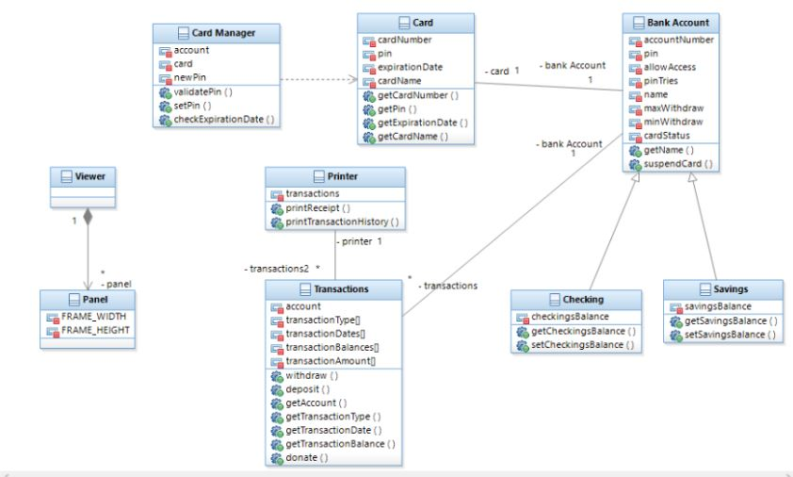Some of the interfaces on the ATM machine are the ‘Card Manager’, the ‘Panel’, and the ‘Printer’. The Card Manager will essentially be a boundary where the card and the ATM machine interact with each other. The Panel is where everything is being outputted visually, meaning that this is a boundary where the system is sending data to the human/user through visuals. And Lastly, The Printer is another boundary where data is outputted to the viewer/user.

**How the Components Relate to Requirements**

The card validation component is related to the card reading requirement and the safety requirement. It takes card information and finds a matching account. It also validates that the pin matches the account using method validatePin().

The UI component and the session component relate to the UI requirement of the ATM. It has a panel which allows for viewer to see a welcome screen and options such as see account information, print receipt, and etc. The banking component also relates to safety requirement. It does not allow for any kind of cash withdrawal without a card, sufficient balance, or unauthorized accounts through card status() and allowAccess(). It also has a maximum amount of times you can try a pin before being locked out.

The session component satisfies the requirement of records. It keeps a copy of each transaction receipt and it can print out a copy for the customer through printReceipt().

The banking component relates to data requirement because cardStatus shows card information such as balance and maxWithdraw which can verify if there are enough funds available to make a withdrawal.

Since we have a simple panel in the UI component the interface is easy to use and organized through panel menu options. Through the banking component it ensures reliability that it does not fail during a transaction through card status.